Practice 3
Part 1
1. Write a query to display the current date. Label the column Date.
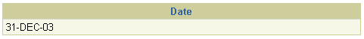
2. The HR department needs a report to display the employee number, last name, salary, and salary increased by 15.5% (expressed as a whole number) for each employee. Label the column New Salary. Place your SQL statement in a text file named lab_03_02.sql.
3. Run your query in the file lab_03_02.sql.
4. Modify your query lab_03_02.sql to add a column that subtracts the old salary from
the new salary. Label the column Increase. Save the contents of the file as lab_03_04.sql. Run the revised query.
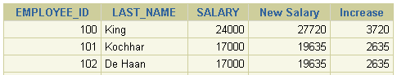
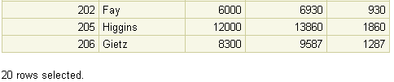
5. Write a query that displays the last name (with the first letter uppercase and all other letters lowercase) and the length of the last name for all employees whose name starts with the letters J, A, or M. Give each column an appropriate label. Sort the results by the employees’ last names.
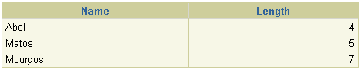
Rewrite the query so that the user is prompted to enter a letter that starts the last name. For example, if the user enters H when prompted for a letter, then the output should show all employees whose last name starts with the letter H.
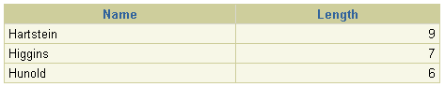
6. The HR department wants to find the length of employment for each employee. For each employee, display the last name and calculate the number of months between today and the date on which the employee was hired. Label the column MONTHS_WORKED. Order your results by the number of months employed. Round the number of months up to the closest whole number.
Note: Your results will differ.
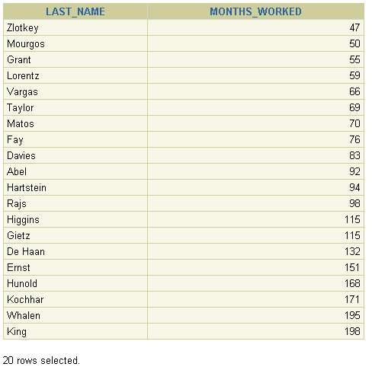
7. Create a report that produces the following for each employee:
<employee last name> earns <salary> monthly but wants <3 times salary>. Label the column Dream Salaries.
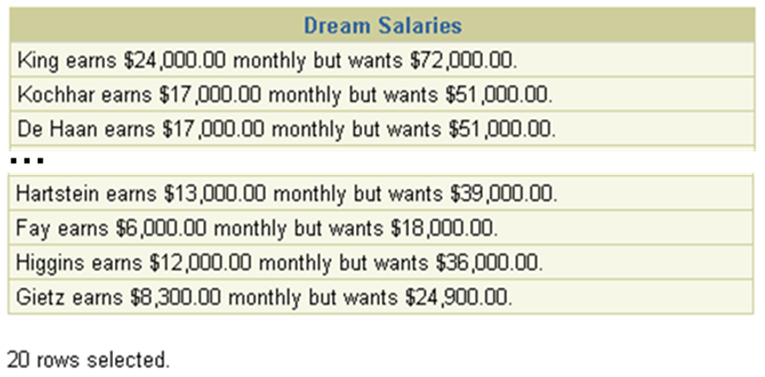
8. Display each employee’s last name, hire date, and salary review date, which is the first Monday after six months of service. Label the column REVIEW. Format the dates to appear in the format similar to “Monday, the Thirty-First of July, 2000.”
